FOR IMMEDIATE RELEASE

This Book Helps You Become A Superhero to Your Children

... instead of facing your children in ten years and answering the question, "Why didn't we do something when we could?"
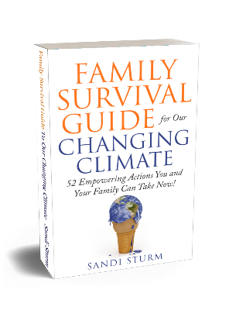

Brookings, Oregon, US, March 15, 2021 -- It is a fact that if we do nothing to reduce our emissions and stop the planet from warming, our children and grandchildren will be faced with the unthinkable consequences!

Do you have a plan to reduce your greenhouse gas emissions to zero by 2050? How about 50% by 2030? That is what we need to do to provide a livable planet for our children.

Do you want to understand how to reduce your carbon footprint 50%, or more, way before the 2030 deadline, but do not know where to start? Do you think you have to make expensive changes to make it happen? Or that you must do them all at once?

Then this book is the answer you have been looking for.

“Everything we do and everything we purchase has a carbon footprint,” says Sandi Sturm, Author of Family Survival Guide for our Changing Climate: 52 Empowering Actions You and Your Family Can Take Now!
I am Sandi Sturm, the founder of Earth Focus Group, with a mission to create a world of people who understand our changing climate and that individual actions affect everyone on earth.
To help individuals reach the recommended goal of reducing emissions 50% by 2030 and 100% by 2050, I have written the book “Family Survival Guide for our Changing Climate: 52 Empowering Actions You and Your Family Can Take Now!”
Me and my husband Wayne travel the US full time in our motorhome. Staying in places two to three months at a time allows us to explore many natural places and the wonderful people who inhabit them.

I also have a National Park habit and am working towards visiting, exploring, and assisting in the preservation of every single one of them.
This book (193 pages) makes it easy for you to take weekly empowering actions to reduce your carbon footprint while putting your budget on a diet, so you can understand how to reduce your carbon footprint 50% or more way before the 2030 deadline. Each of the 52 empowering actions has a bit of background information, a suggested family action and a community action.
- Gets You More Confidence in Preparing Your Children for Their Future
- Makes It Easy to Take Empowering Actions to Reduce Your Family's Carbon Footprint
- Gives You the Knowledge and Understanding of The Effects Climate Change Has on Your Family
- ​Avoids the Dreaded Conversation with Your Children in Ten Years When They Ask, "Why Did We Do Nothing?"
- ​Quickly Understand Why We Need to Teach Our Children These Behaviors
- ​Escape the Parental Guilt of Doing Nothing
- ​Discover Ways to Involve the Community
Contact:
Sandi Sturm, author
970-424-3404
Sandi@EarthFocusGroup.com – to request a review copy
https://facebook.com/EarthFocusGroupUS
https://www.linkedin.com/in/sandisturm
Available for podcast interviews.
I have purchased paperback copies for you. All I ask is that you pay shipping and handling of $9.95. Go to https://the52actionsbook.com to get your copy.
###

